

**Amazing Online Shop**

Amazing Online Shop

A Project Report

*Submitted by*

Jadhav Rupesh (225490694039)

Jain Mohit (225490694040)

Prajapati Kashyap (225490694087)

*In a partial fulfillment for the award of the degree of*

Master of Computer Applications

In

Information Technology

RB Institute of Management Studies – Ahmedabad

Gujarat Technological University, Ahmedabad

April, 2024

**Acknowledgement**

I have taken efforts in this seminar report. However, it would not have been possible without the kind support and help of many individuals. I would like to extend my sincere thanks to all of them.

I am highly indebted to Prof. **Zalak Patel** for this guidance and supervisions well as for providing necessary information regarding the seminar.

I would like to express my gratitude towards my lovely parents for their co-operation and encouragement which help me in completion of this seminar report.

My Thanks and appreciations also go to my friends who helped me out their abilities.

I am Thankful to all our staff members who helped continuously and inspired me in the project.

Jadhav Rupesh (225490694039)

Jain Mohit (225490694040)

Prajapati Kashyap (225490694087)

|  |  |
| --- | --- |
| INDEX | |
| Sr. No | Contents |
| 1 | **Introduction** |
|  | * 1. Existing System |
|  | * 1. Need for the new System |
|  | * 1. Objective for new System |
|  | * 1. Problem Definition |
|  | * 1. Core Components |
|  | * 1. Project Profile |
|  | * 1. Assumptions and Constraints |
|  | * 1. Advantages and Limitations of the Proposed System |
| 2 | **Requirement Determination & Analysis** |
|  | 2.1. Requirement Determination |
|  | 2.2. Targeted Users |
| 3 | **System Design** |
|  | 3.1. Use Case Diagram |
|  | 3.2. Class Diagram |
|  | 3.3. Interaction Diagram |
|  | 3.4. Activity Diagram |
|  | 3.5. Data Dictionary |
| 4 | **Development** |
|  | 4.1. Coding Standards |
|  | 4.2. Screen Shots |
| 5 | **Agile Documentation** |
|  | 5.1 Agile Project Charter |
|  | 5.2 Agile Roadmap / Schedule |
|  | 5.3 Agile Project Plan |
|  | 5.4 Agile User Story (Minimum 3 Tasks) |
|  | 5.5 Agile Release Plan |
|  | 5.6 Agile Sprint Backlog |
|  | 5.7 Agile Test Plan |
|  | 5.8 Earned-value and burn charts |
| 6 | **Proposed Enhancements** |
| 7 | **Conclusion** |
| 8 | **Bibliography** |

**Existing System**

Implement a user-friendly online platform where customers can browse, search, and purchase products from the comfort of their homes. This eliminates the need for customers to physically visit the shop.

Enhance the product browsing experience by implementing intuitive search and filter functionalities.

Provide detailed product descriptions, including images, specifications, and customer reviews. This helps customers make informed purchasing decisions without physically inspecting the products.

Simplify the checkout process by integrating secure payment gateways and offering multiple payment options, such as credit/debit cards, mobile wallets, and cash on delivery.

This reduces the time and effort required for completing a purchase.

Existing systems may lack the efficiency of automated systems, leading to a higher risk of double bookings or wrong bookings conflicts.

By contrast, an Amazing Online Shop provides real-time booking and scheduling functionality, allowing customers to Place Order at their convenience and receive instant confirmation. Additionally, the Amazing Online Shop can provide real-time reporting and analytics, allowing managers to track performance and make informed decisions about Stocks available or not and check the Order and its Details.

**Need for the new System**

**User Interface**: The proposed system should have an easy-to-use interface that allows customers to purchase a product(s) easily. The user interface should be simple and intuitive, allowing customers to quickly buy their desired products without any confusion.

**Services**: The system should allow shop owners to create a list of services they offer and their corresponding prices. Like delivery charges and discount coupon codes, Customers should be able to view the available services and select the ones they want to book.

**Availability**: The system should provide real-time information on the availability of products. Customers should be able to see that product is available or not.

**Reviews** **and** **Ratings**: The system should allow customers to leave reviews and ratings for the product they have received. This feature would help the shop owners to improve their services and attract more customers.

**Objective for new System**

**Enhance Customer Convenience and Satisfaction:** The Amazing Online Shop aims to provide a user-friendly interface and seamless shopping experience, including intuitive navigation, personalized recommendations, and secure payment options, to maximize customer satisfaction.

**Improved User Experience**: The new system should provide a user-friendly interface that is easy to navigate and allows users to place order and manage order quickly and easily.

**Increased Efficiency**: The new system should automate many manual tasks, reducing the workload on staff and improving the overall efficiency of the Shop.

**Greater Visibility**: The new system should provide real-time data on dashboard like customer, orders, and customer feedback, allowing shop owners to make informed business decisions.

**Customization**: The new system should allow shop owners to customize the system to their specific needs, including branding, size, color and pricing.

**Security**: The new system should provide robust security features to protect customer data and prevent unauthorized access.

**Mobile Accessibility**: The new system should have a mobile-friendly interface and a mobile app version to allow customers to place orders on the mobile devices.

**Competitive Advantage**: The new system should provide a competitive advantage for the shop by offering a superior order experience, better customer service, and improved efficiency.

**Problem Definition**

* The existing process of Online shopping saves time and effort by eliminating the need for travel, parking, and waiting in queues.
* Online shopping provides access to a vast range of products from various sellers and brands. Shoppers can easily compare prices, read product reviews, and find unique or niche items that may not be available in local stores.
* Delivery tracking systems allow customers to monitor the progress of their shipments and plan accordingly.

**Project Profile**

* **Project Name**: Amazing Online Shop
* **Objective**: To develop a robust e-commerce platform, the Amazing Online Shop, leveraging the Laravel framework for PHP, HTML, CSS, JavaScript, Ajax, and jQuery, to facilitate seamless online shopping experiences for customers and streamline operations for businesses, ultimately driving sales and revenue growth.
* **Scope:**
  + A Develop a comprehensive e-commerce website, the Amazing Online Shop, allowing users to browse, search, and purchase products conveniently.
  + Implement user authentication and profile management functionalities for customers and administrators.
  + Integrate secure payment gateways to facilitate online transactions and ensure data protection.
  + Provide administrative tools for managing products, categories, promotions, and user accounts.

**Assumptions and Constraints**

* **Assumptions:**
* The successful operation of the Amazing Online Shop assumes that users will have access to a stable internet connection to browse the website and complete transactions.
* It is assumed that sufficient server capacity and bandwidth will be available to handle website traffic, ensuring smooth performance during peak periods.
* The system will increase revenue and customer satisfaction for shop.
* Integration with payment gateways and third-party applications will be feasible and effective.
* The project assumes that users will be familiar with the concept of online shopping and comfortable using digital platforms to make purchases.
* **Constraints**
* Time frame for project completion.
* Availability of resources and budget.
* Legal and regulatory requirements for data privacy and security.
* Compatibility with existing Online Shopping Websites.
* Scalability of the system to accommodate future growth and changes in business requirements.

**Advantages and Limitations of the Proposed System**

* **Advantages**
  + **Increased Efficiency**: The Amazing Online Shop offers customers the convenience of shopping from anywhere at any time, eliminating the need to visit physical stores.
  + **Improved Operational Efficiency:** Automation of various processes such as inventory management, order processing, and payment handling streamlines operations and reduces overhead costs.
  + **Improved Customer Experience**: Amazing online shop can provide customers with an easy and convenient way to buy services, reducing wait times and improving the overall customer experience.
  + **Real-Time Updates**: Customers and staff can receive real-time updates about order changes, cancellations, and other important information.
  + **Data Analysis**: Businesses can access real-time data and analytics to track sales performance, monitor customer behavior, and make informed decisions to optimize operations and marketing strategies.
* **Limitation**
  + **Technical Issues:** The successful operation of the Amazing Online Shop relies on stable internet connectivity and the availability of reliable server infrastructure, which may be subject to technical disruptions.
  + **Security Concerns:** Online transactions carry inherent security risks such as data breaches and fraud, necessitating robust security measures to protect sensitive customer information.
  + **User Adoption Challenges:**  Some users may be hesitant to embrace online shopping due to concerns about privacy, security, or unfamiliarity with digital platforms, limiting the platform's adoption.
  + **Competition:** The e-commerce market is highly competitive, with numerous players vying for customers' attention, making it challenging for new entrants like the Amazing Online Shop to establish a foothold.
  + **Maintenance and Upkeep:** Maintaining and updating the platform requires ongoing investment in resources and technology, which may pose financial and logistical challenges for businesses.

**Requirement Determination**

**Identify stakeholders**: The first step is to identify the stakeholders who will be using the system, including customers, shop owners and staff, payment gateway providers, third-party application providers, and customer support personnel.

**Gather requirements**: The requirements gathering process involves collecting information from the stakeholders about their needs, preferences, and expectations for the system. This can be done through surveys, interviews, focus groups, and other methods.

**Prioritize requirements**: Once the requirements have been gathered, they need to be prioritized based on their importance and feasibility. This involves ranking the requirements according to their business value, technical complexity, and time and resource constraints.

**Define use cases**: Use cases are scenarios that describe how the system will be used by different stakeholders. Use cases help to identify the system's functional requirements and ensure that they are aligned with the stakeholders' needs.

**Analyze requirements:** Requirements analysis involves reviewing the requirements to ensure that they are complete, consistent, and unambiguous. This involves validating the requirements with the stakeholders and identifying any conflicts or gaps.

**Document requirements**: The requirements need to be documented in a clear and concise manner, using standard templates and formats. This documentation serves as a reference for the development team and ensures that the stakeholders are aware of the system's functionality and features.

**Review and refine requirements**: Finally, the requirements need to be reviewed and refined throughout the development process to ensure that they remain relevant and accurate. This involves continuous communication and collaboration between the stakeholders and the development team.

**Targeted Users**

**Customers**: Individuals from various demographics seeking to purchase products conveniently online. This includes tech-savvy millennials, busy professionals, parents, and elderly individuals. Users are looking for a seamless and hassle-free shopping experience, with access to a wide range of products and secure payment options.

**Shop owners**: Platform administrators responsible for managing and overseeing the operations of the Amazing Online Shop. This includes tasks such as managing product listings, processing orders, handling customer inquiries, and analyzing sales data to optimize performance.

**Use Case Diagram**

* Use Case diagram provide a simple and fast means to decide & describe the purpose of a project.
* It is one type of interaction model & it is describe how object interact to produce useful result.
* At high level use case describes how a system interacts with outside actor.
* Each usecase represent functionality of a system along with users.
* A system involves a set of usecases and a set of actors.
* 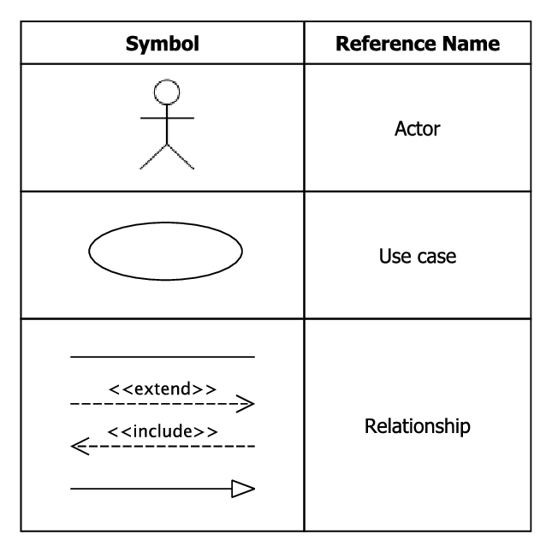Each usecase represent functionality of the system & set of usecase represent the complete functionality of system.

**Admin Side Usecase**

**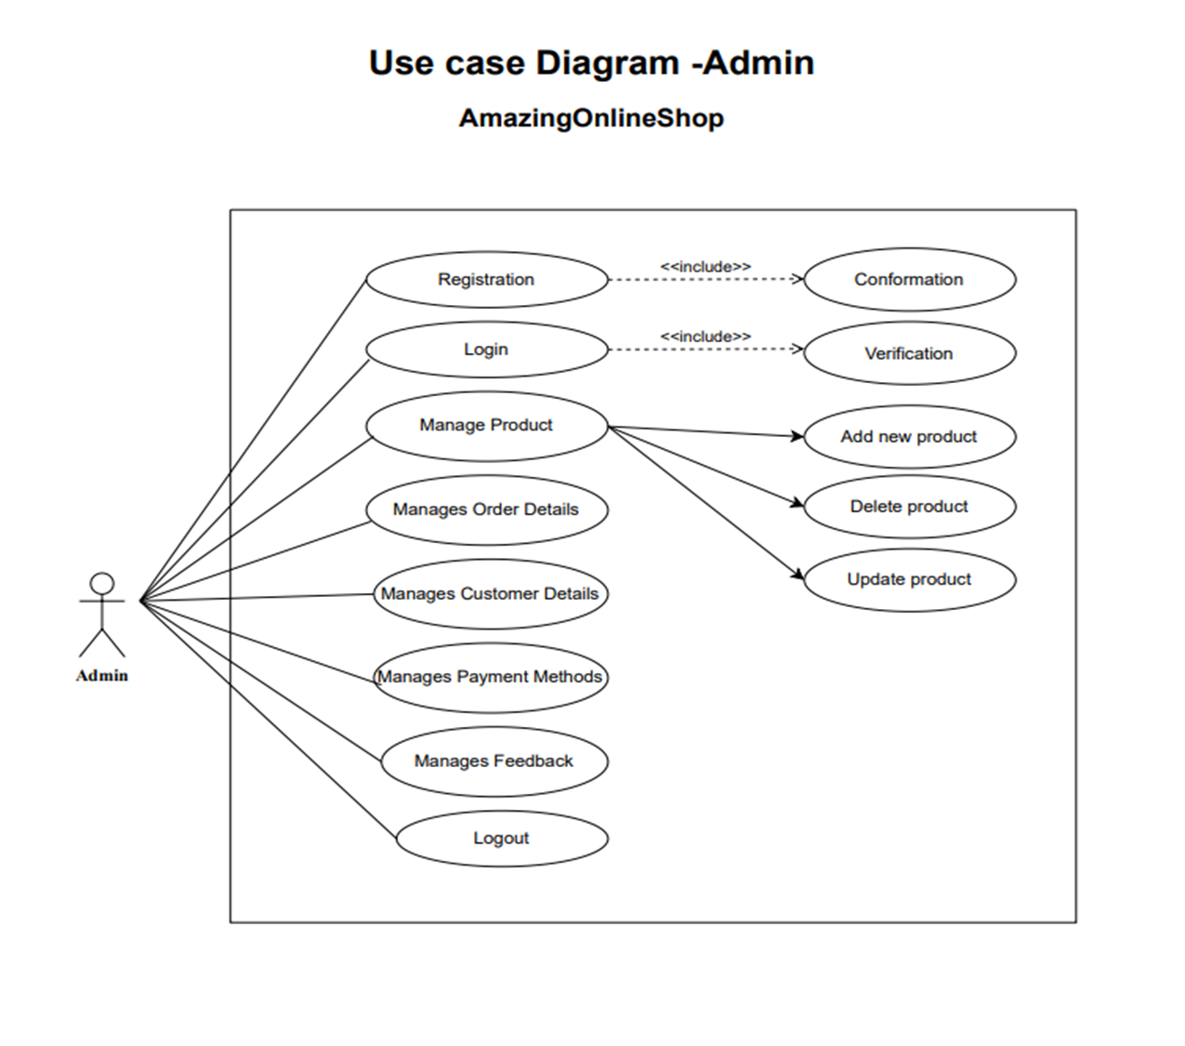**

**Customer Side Usecase**

**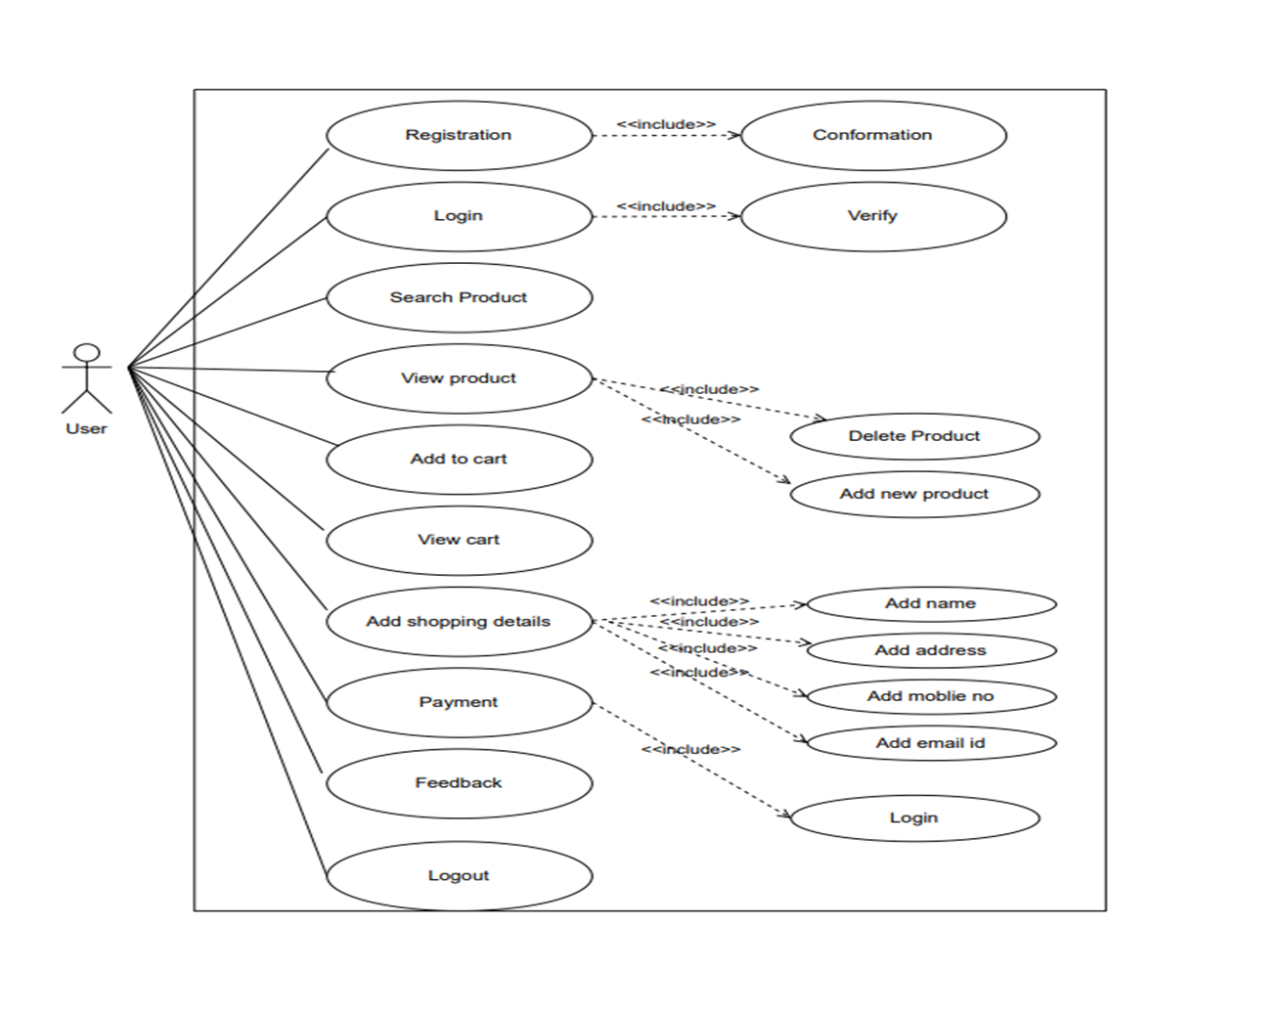**

**Class Diagram**

* A [class diagram](https://creately.com/diagram-type/uml-class-diagrams) is a UML diagram type that describes a system by visualizing the different types of objects within a system and the kinds of static relationships that exist among them.
* It also illustrates the operations and attributes of the classes.
* They are usually used to explore domain concepts, understand software requirements and describe detailed designs.
* 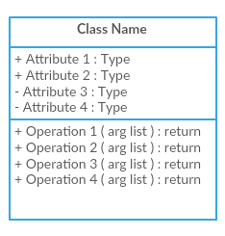 Class Diagram Components: -

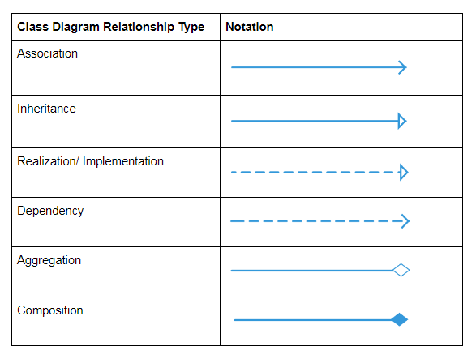

**Class Diagram**

**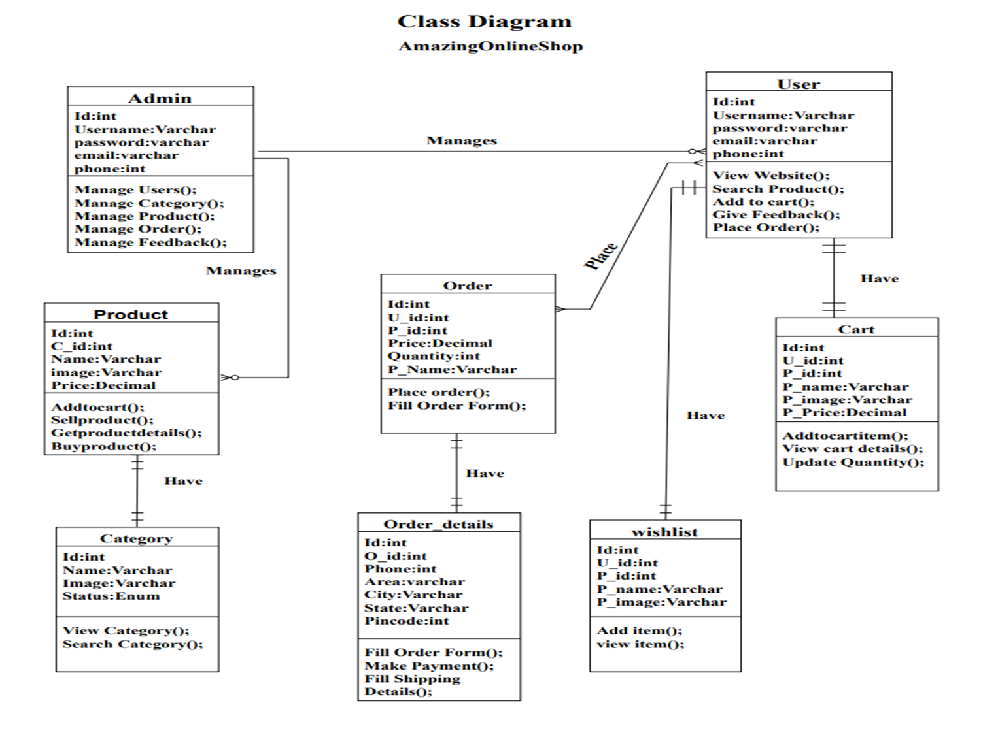**

**Interaction Diagram**

* A sequence diagram shows, as parallel lines, different process or object that live simultaneously and as horizontal arrows, the message exchanged between them, in the order in which they occur.
* Sequence diagram are typically associated with use case realizations in the logical view of the system under development
* Sequence diagram are sometime called event diagram or event scenarios.
* Each usecase represent functionality of a system along with users.

**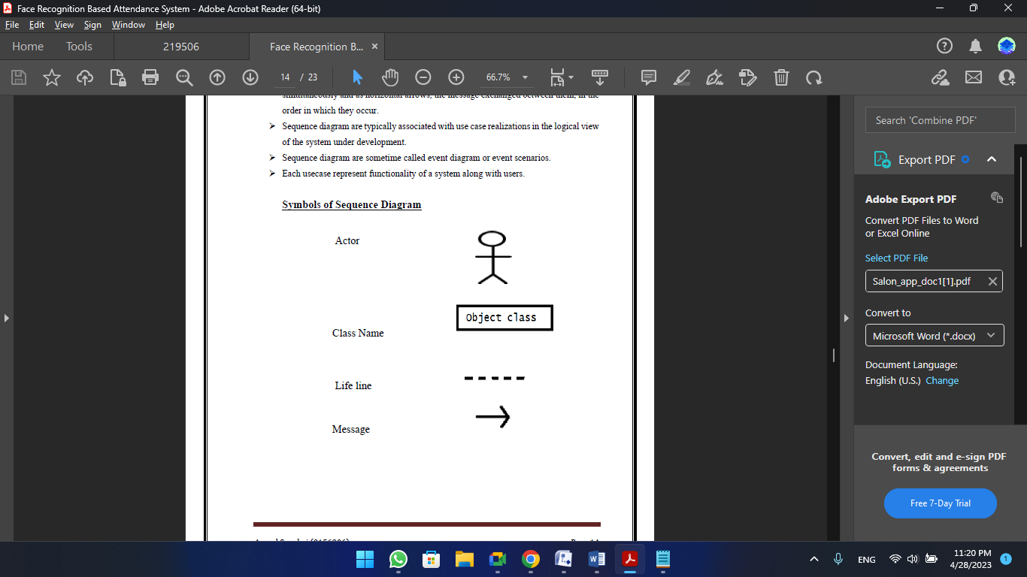Symbols of Sequence Diagram**

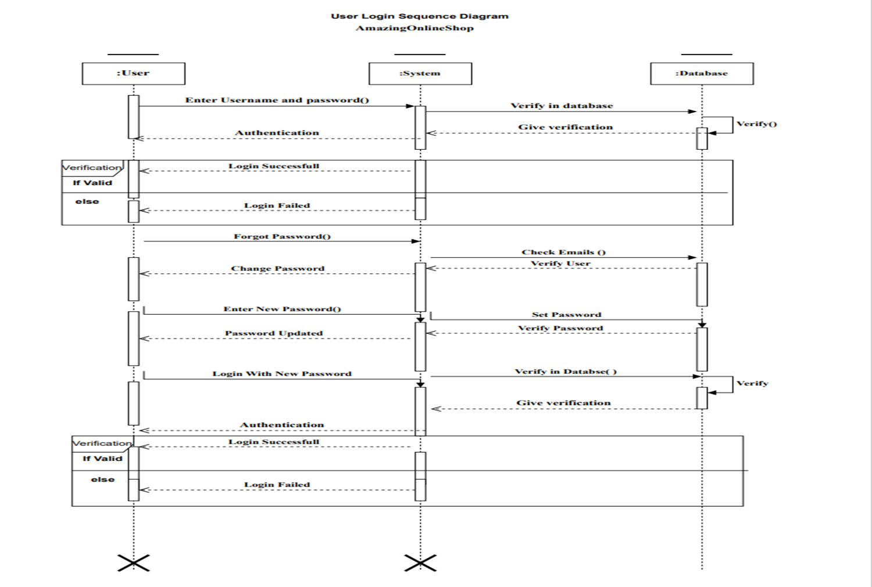**User Login Sequence Diagram**

**Admin Side Sequence Diagram**

**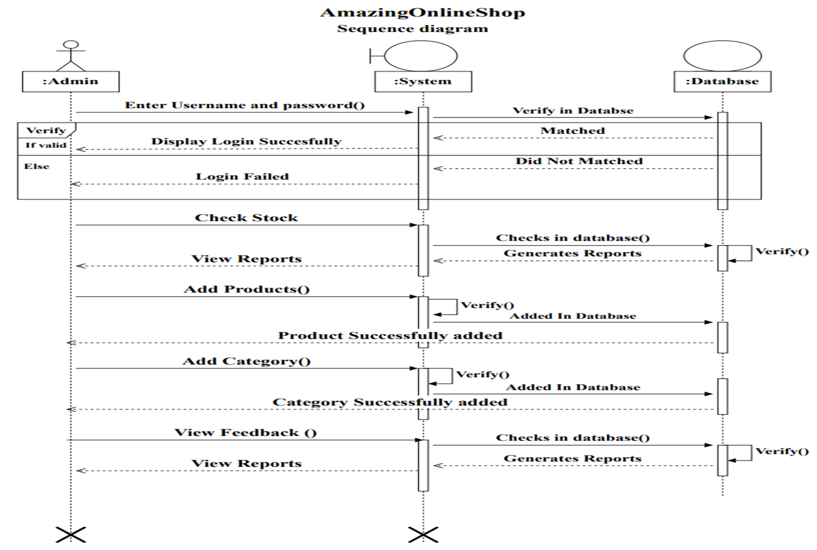**

**Activity Diagram**

* It is the Equivalent to flow chart diagram.
* It showing flow of control from activity to activity.
* It is used for modeling the logic captured by a single usecase Scenario.
* Activity diagram is used for simple and perspective Illustration of what happens in a work flow, what activities Can be done in parallel & whether there is alternative path through the work flow.
* It shows the work flow from a start point of the finish point.

**Symbols of Activity Diagram**

**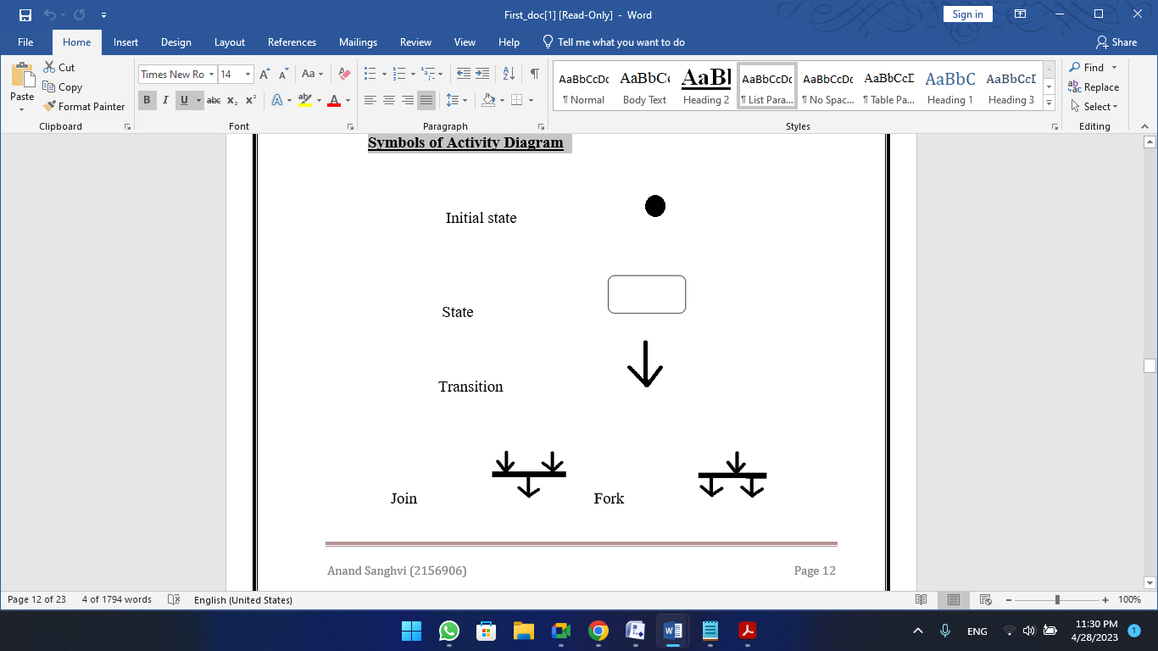**

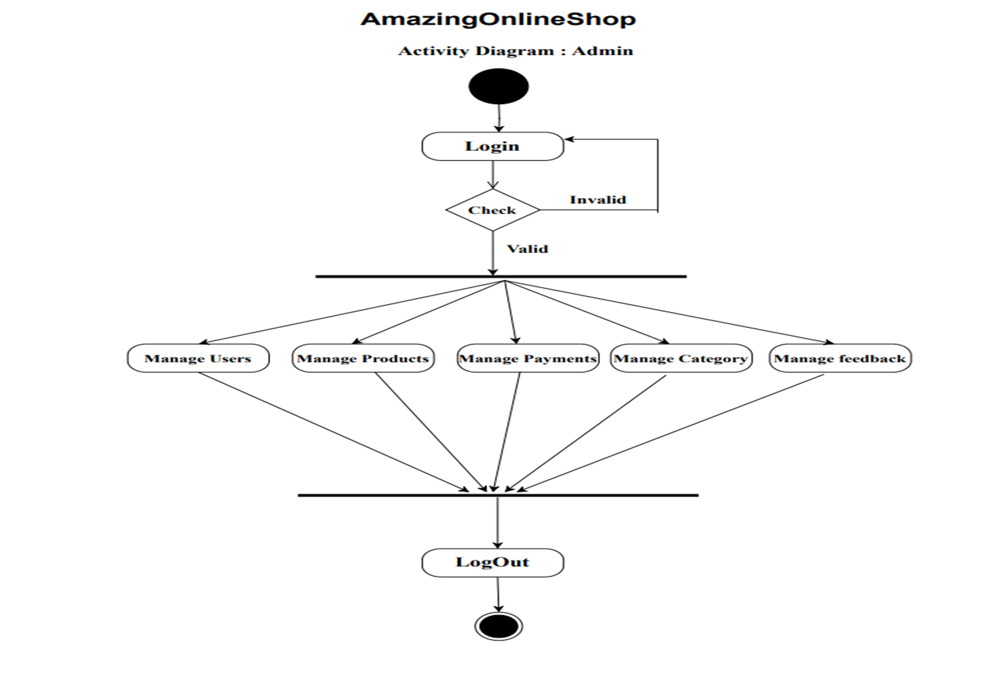**Admin Side Activity Diagram**

**User Side Activity Diagram**

**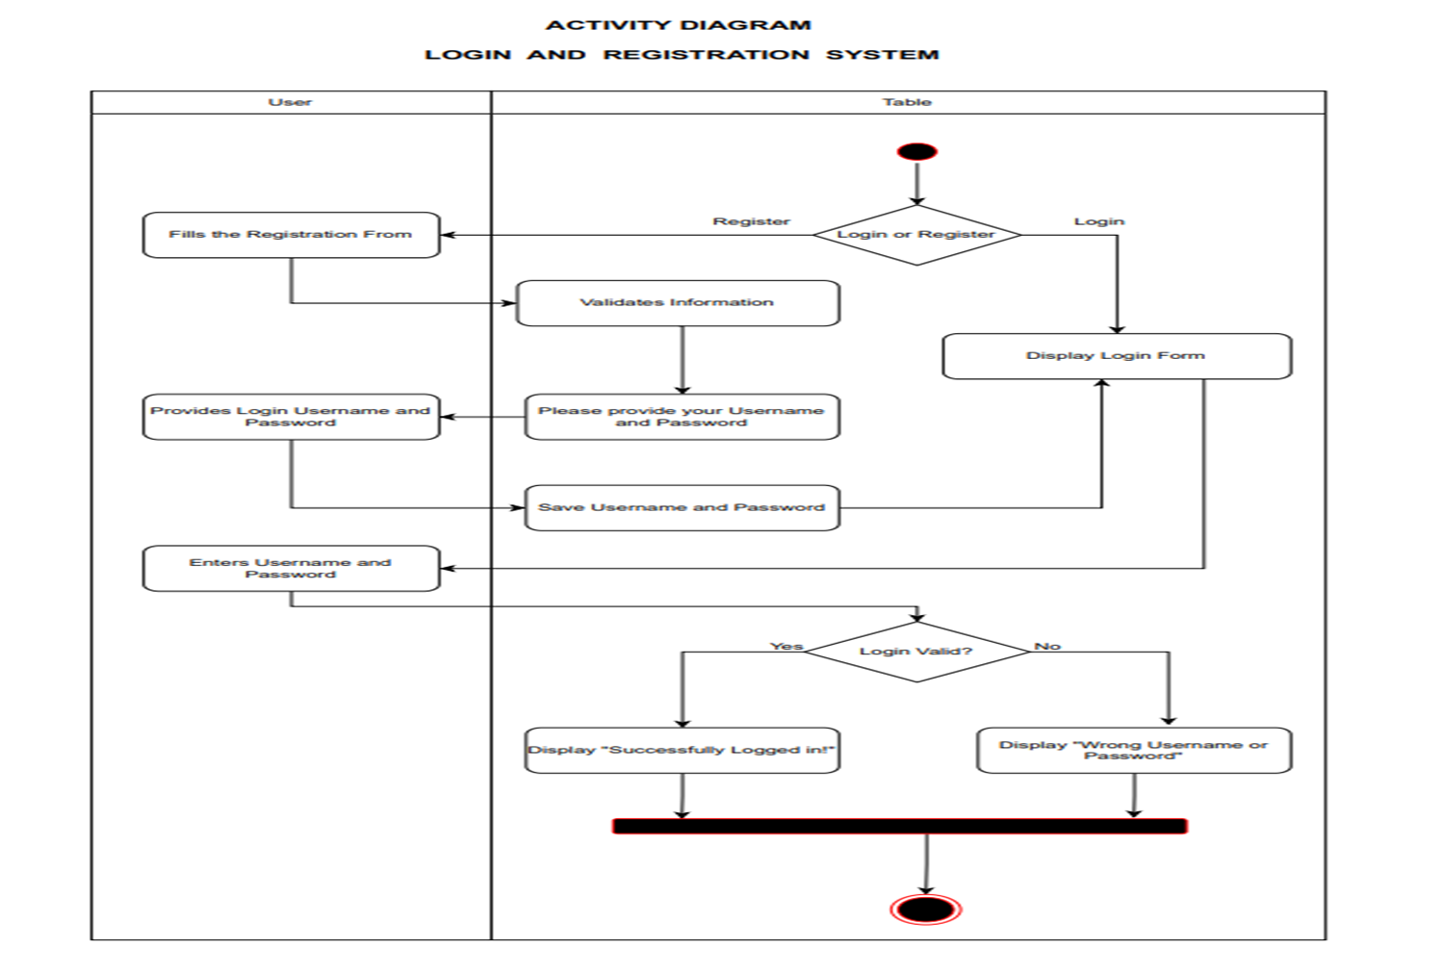**

**Data Dictionary**

**Table :1 User**

|  |  |  |  |
| --- | --- | --- | --- |
| Name | Data Type | Not Null | Key |
| id | Int | Yes | PK |
| name | Varchar (191) | Yes | - |
| email | Varchar (191) | Yes | - |
| phone | Varchar | - | - |
| role | Int (11) | Yes | - |
| status | Int (11) | Yes | - |
| password | Varchar (255) | Yes | - |
| created\_at | Timestamp | - | - |
| updated\_at | Timestamp | - | - |

**Table :2 Category**

|  |  |  |  |
| --- | --- | --- | --- |
| Name | Data Type | Not Null | Key |
| id | Int | Yes | PK |
| name | Varchar (191) | Yes | - |
| slug | Varchar (191) | Yes | - |
| image | Varchar (191) | - | - |
| status | Int (11) | Yes | - |
| created\_at | Timestamp | - | - |
| updated\_at | Timestamp | - | - |

**Table :3 Brands**

|  |  |  |  |
| --- | --- | --- | --- |
| Name | Data Type | Not Null | Key |
| id | Int | Yes | PK |
| name | Varchar (191) | Yes | - |
| slug | Varchar (191) | Yes | - |
| status | Int | Yes | - |
| created\_at | Timestamp | - | - |
| updated\_at | Timestamp | - | - |

**Table :4 Contact (User Query’s)**

|  |  |  |  |
| --- | --- | --- | --- |
| Name | Data Type | Not Null | Key |
| id | Int | Yes | PK |
| name | Varchar (191) | Yes | - |
| email | Varchar (191) | Yes | - |
| subject | Varchar (191) | Yes | - |
| message | text | - | - |
| created\_at | Timestamp | Yes | - |
| updated\_at | Timestamp | Yes | - |

**Table :5 Discount Coupons**

|  |  |  |  |
| --- | --- | --- | --- |
| Name | Data Type | Not Null | Key |
| id | Int | Yes | PK |
| code | Varchar (191) | Yes | - |
| name | Varchar (191) | - | - |
| description | text | - | - |
| max\_uses | Int | - | - |
| max\_uses\_user | Int | - | - |
| Type | Enum | Yes | - |
| discount\_amount | Double | Yes | - |
| min\_amount | Double | - | - |
| status | Int | Yes | - |
| starts\_at | Timestamp | - | - |
| expires\_at | Timestamp | - | - |
| created\_at | Timestamp | - | - |
| updated\_at | Timestamp | - | - |

**Table :6 Pages**

|  |  |  |  |
| --- | --- | --- | --- |
| Name | Data Type | Not Null | Key |
| id | Int | Yes | PK |
| name | Varchar (191) | Yes | - |
| slug | Varchar (191) | Yes | - |
| content | Text | - | - |
| created\_at | Timestamp | - | - |
| updated\_at | Timestamp | - | - |

**Table :7 Products**

|  |  |  |  |
| --- | --- | --- | --- |
| Name | Data Type | Not Null | Key |
| id | Int | Yes | PK |
| title | Varchar (191) | Yes | - |
| slug | Varchar (191) | Yes | - |
| description | Text | - | - |
| short\_description | Text | - | - |
| shipping\_returns | Text | - | - |
| related\_products | Text | - | - |
| price | Double | Yes | - |
| compare\_price | Double | - | - |
| category\_id | Int | Yes | FK |
| sub\_category\_id | Int | Yes | FK |
| brand\_id | Int | Yes | FK |
| is\_featured | Enum | Yes | - |
| sku | Varchar (191) | Yes | - |
| track\_qty | Enum | - | - |
| qty | Enum | - | - |
| status | Int | Yes | - |
| created\_at | Timestamp | - | - |
| updated\_at | Timestamp | - | - |

**Table : 8 Product Images**

|  |  |  |  |
| --- | --- | --- | --- |
| Name | Data Type | Not Null | Key |
| id | Int | Yes | PK |
| product\_id | Int | Yes | FK |
| image | Varchar (191) | Yes | - |
| created\_at | Timestamp | - | - |
| updated\_at | Timestamp | - | - |

**Table :9 Product Ratings**

|  |  |  |  |
| --- | --- | --- | --- |
| Name | Data Type | Not Null | Key |
| id | Int | Yes | PK |
| product\_id | Int | Yes | FK |
| username | Varchar (191) | Yes | - |
| email | Varchar (191) | Yes | - |
| comment | Varchar (191) | Yes | - |
| rating | Double | Yes | - |
| status | Int | Yes | - |
| created\_at | Timestamp | - | - |
| updated\_at | Timestamp | - | - |

**Table:10 Orders**

|  |  |  |  |
| --- | --- | --- | --- |
| Name | Data Type | Not Null | Key |
| id | Int | Yes | PK |
| user\_id | Int | Yes | FK |
| subtotal | Double | Yes | - |
| shipping | Double | Yes | - |
| coupon\_code | Varchar (191) | - | - |
| coupon\_code\_id | Varchar (191) | - | - |
| related\_products | Text | - | - |
| discount | Double | - | - |
| grand\_total | Double | Yes | - |
| payment\_status | Enum | Yes | - |
| payment\_mode | Enum | Yes | - |
| status | Int | Yes | - |
| shipped\_date | Timestamp | - | - |
| first\_name | Varchar (191) | Yes | - |
| last\_name | Varchar (191) | Yes | - |
| email | Varchar (191) | Yes | - |
| mobile | Varchar (191) | Yes | - |
| country\_id | Int | Yes | FK |
| address | Text | Yes | - |
| zip | Varchar (191) | Yes | - |
| notes | Text | - | - |
| created\_at | Timestamp | - | - |
| updated\_at | Timestamp | - | - |

**Table:11 Order Items**

|  |  |  |  |
| --- | --- | --- | --- |
| Name | Data Type | Not Null | Key |
| id | Int | Yes | PK |
| order\_id | Int | Yes | FK |
| product\_id | Int | Yes | FK |
| Name | Varchar (191) | Yes | - |
| qty | Int | Yes | - |
| price | Double | Yes | - |
| total | Double | Yes | - |
| created\_at | Timestamp | - | - |
| updated\_at | Timestamp | - | - |

**Table:11 Sub Category**

|  |  |  |  |
| --- | --- | --- | --- |
| Name | Data Type | Not Null | Key |
| id | Int | Yes | PK |
| name | Varchar (191) | Yes | - |
| slug | Varchar (191) | Yes | - |
| status | Int | Yes | - |
| showHome | Enum | Yes | - |
| category\_id | Int | Yes | FK |
| created\_at | Timestamp | - | - |
| updated\_at | Timestamp | - | - |

**Table:12 Wishlists**

|  |  |  |  |
| --- | --- | --- | --- |
| Name | Data Type | Not Null | Key |
| id | Int | Yes | PK |
| user\_id | Int | Yes | FK |
| product\_id | Int | Yes | FK |
| created\_at | Timestamp | - | - |
| updated\_at | Timestamp | - | - |

**Screen Layouts**

**Home Screen Page**

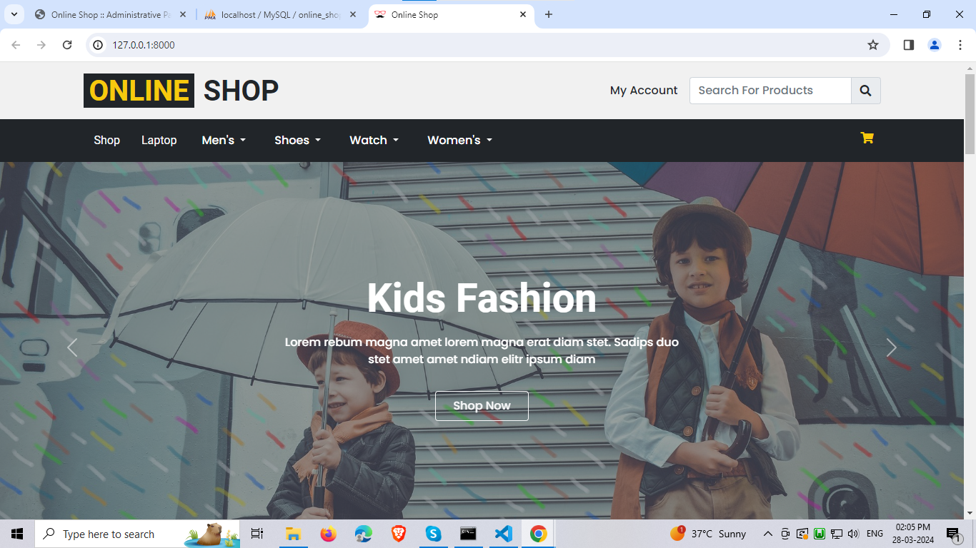

**Featured Product Page**

**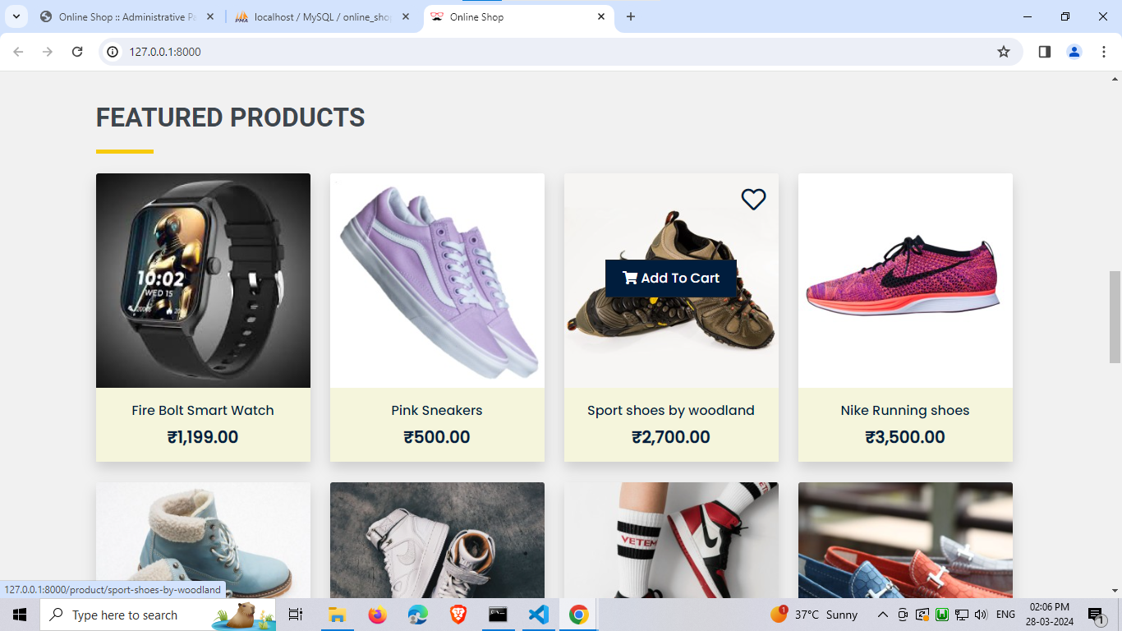**

**Shop Page**

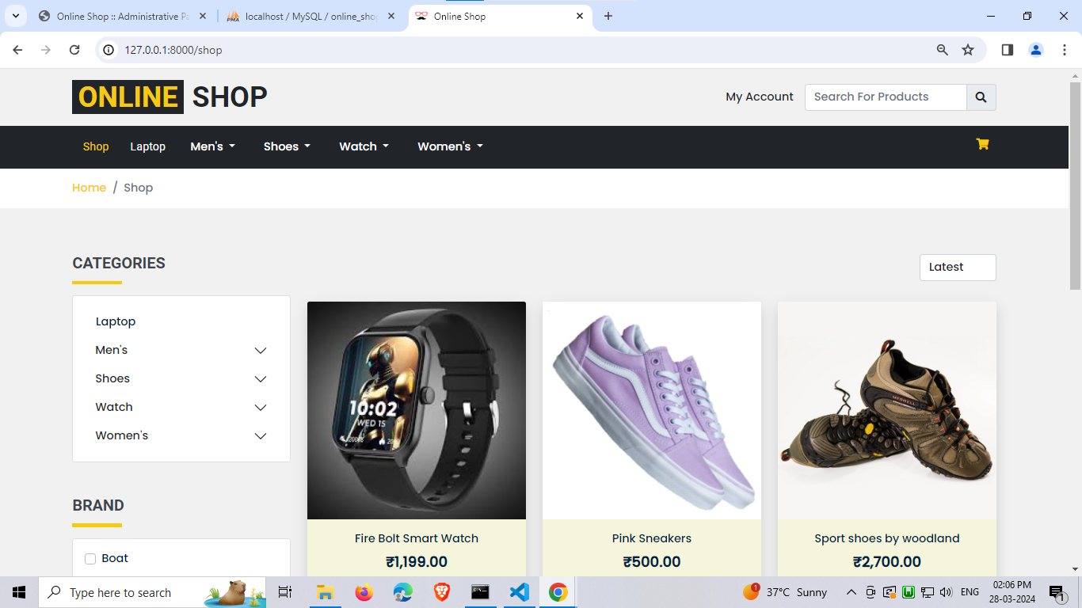

**Selected Product Page**

**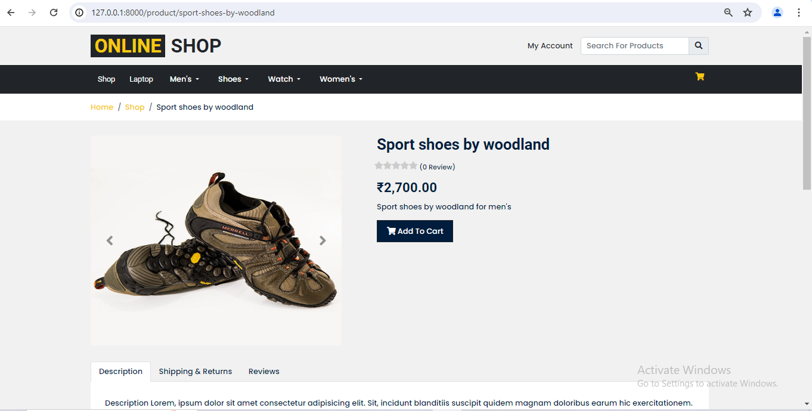**

**Cart Page**

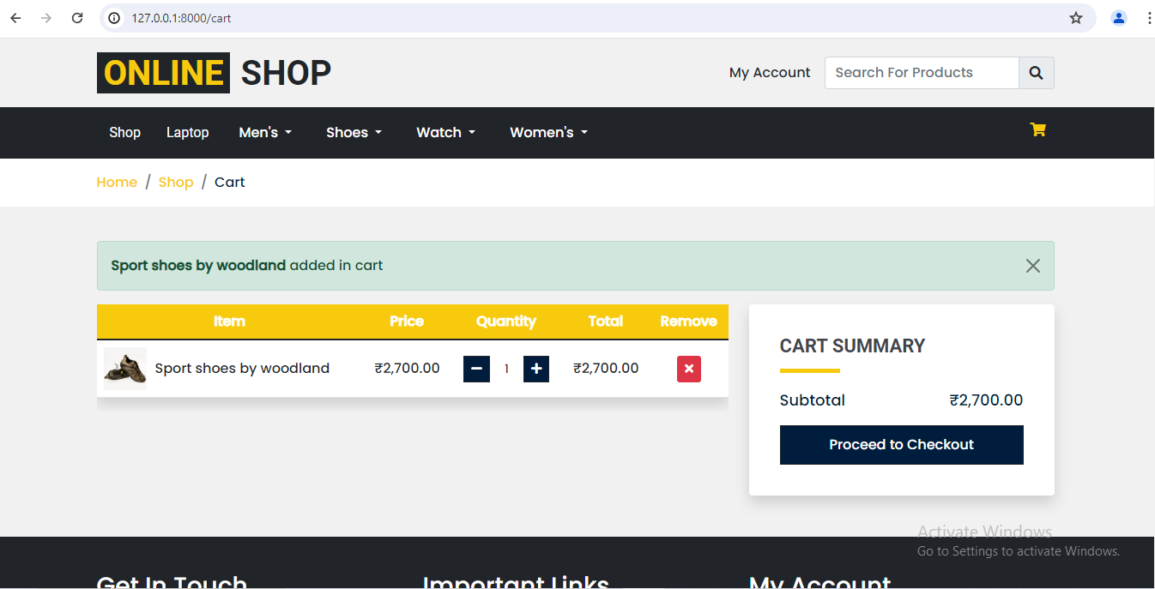

**Registration Page**

**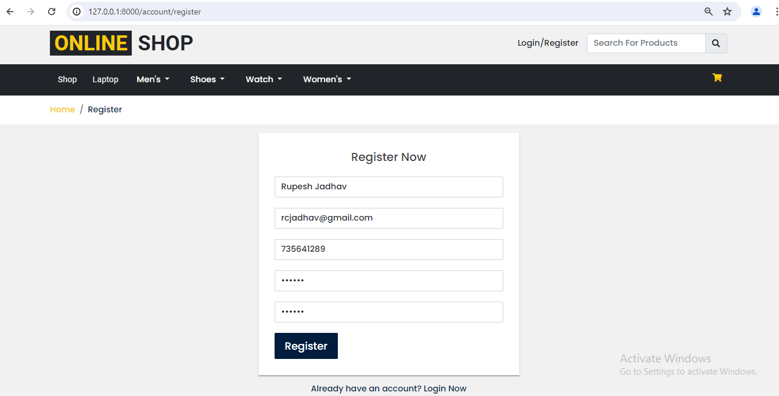**

**Login Page**

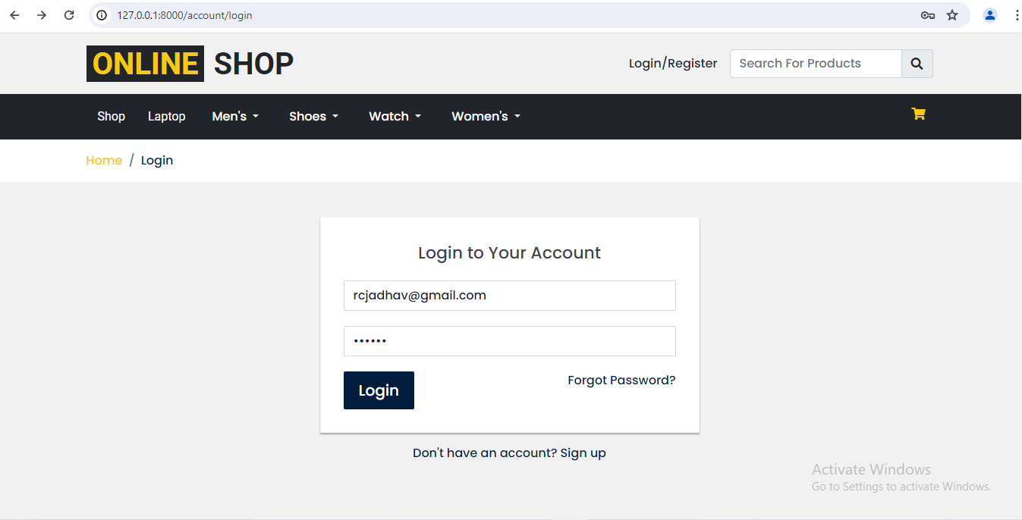

**Checkout Page**

**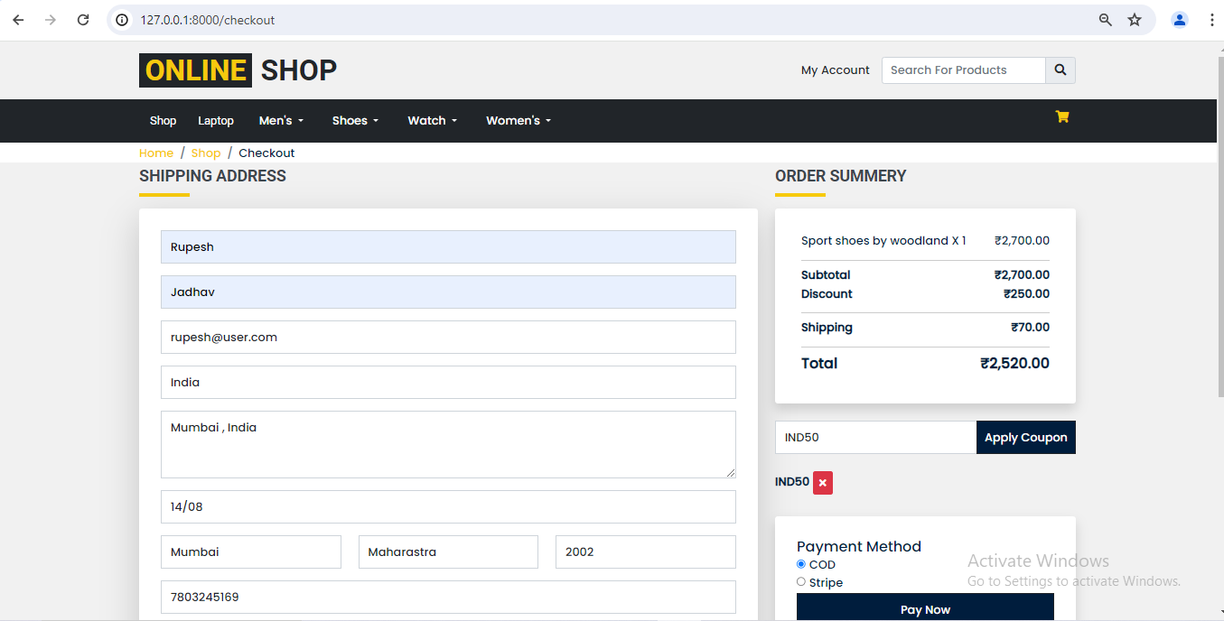**

**Order Success Page**

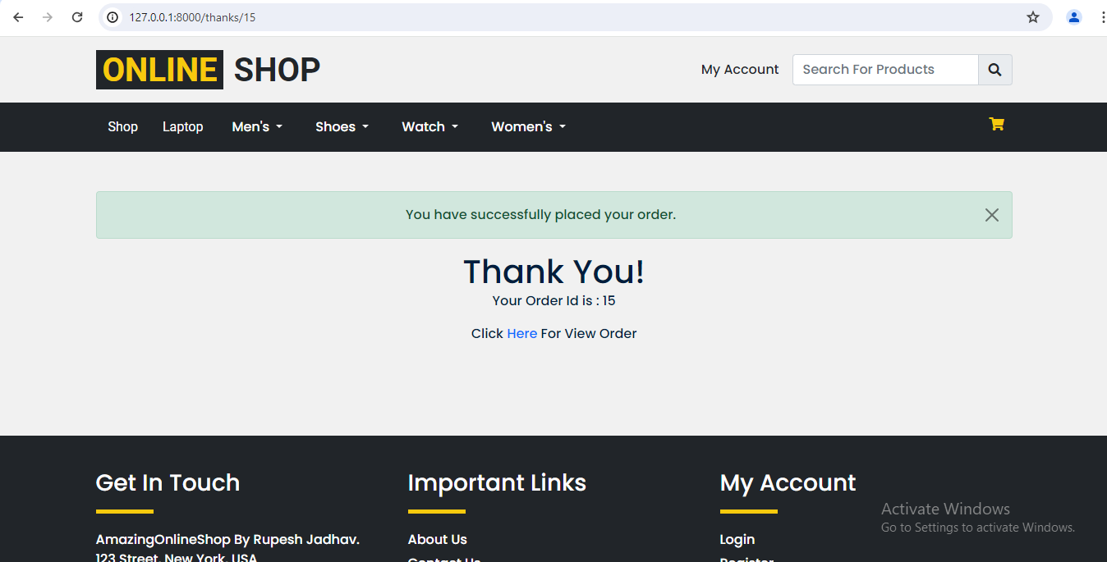

**My Order Page**

**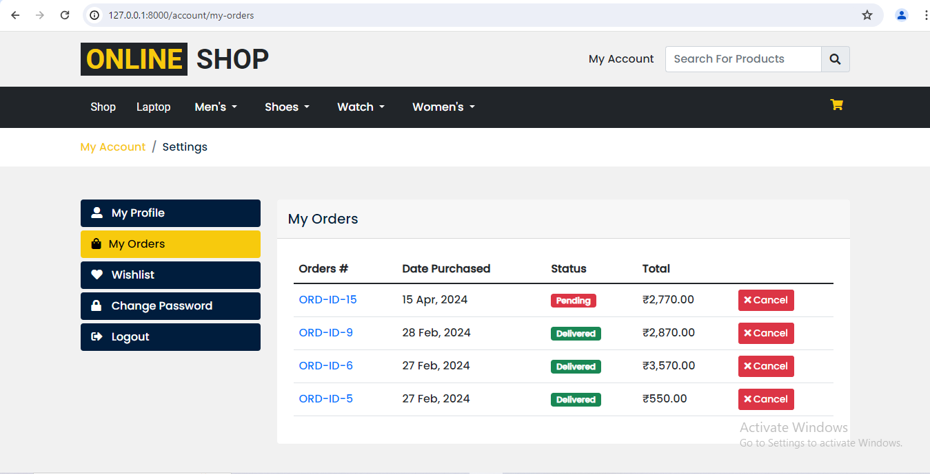**

**Order Details Page**

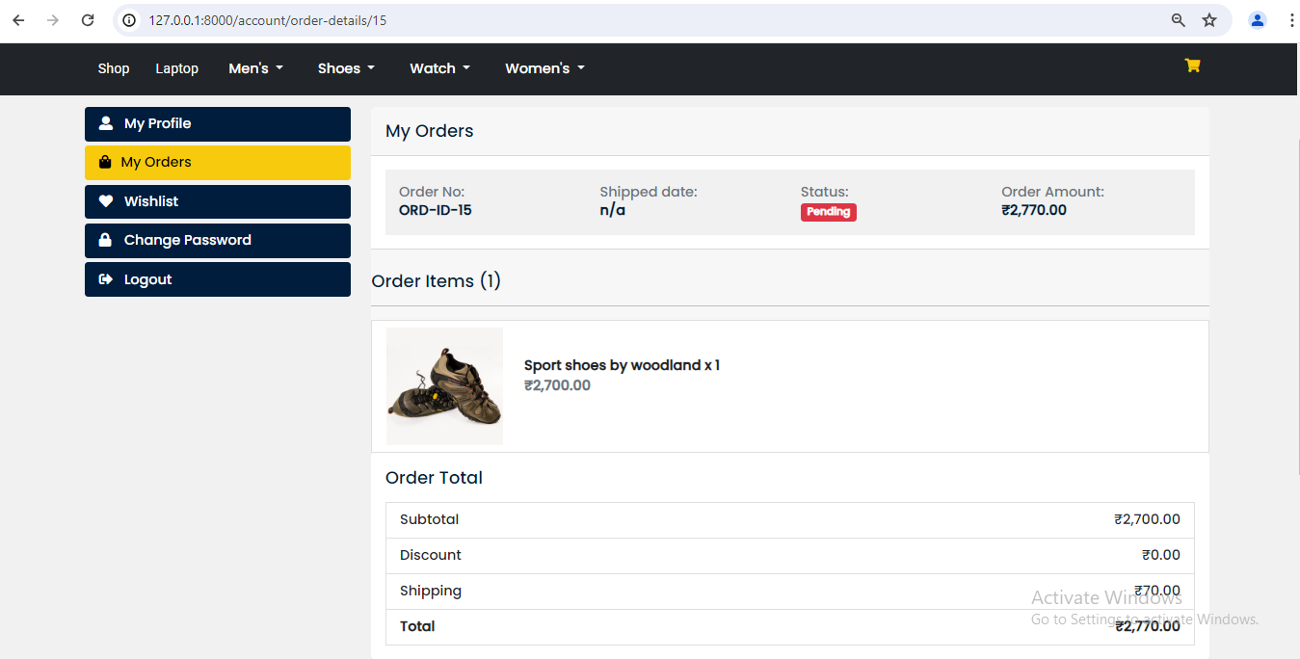

**Profile Page**

**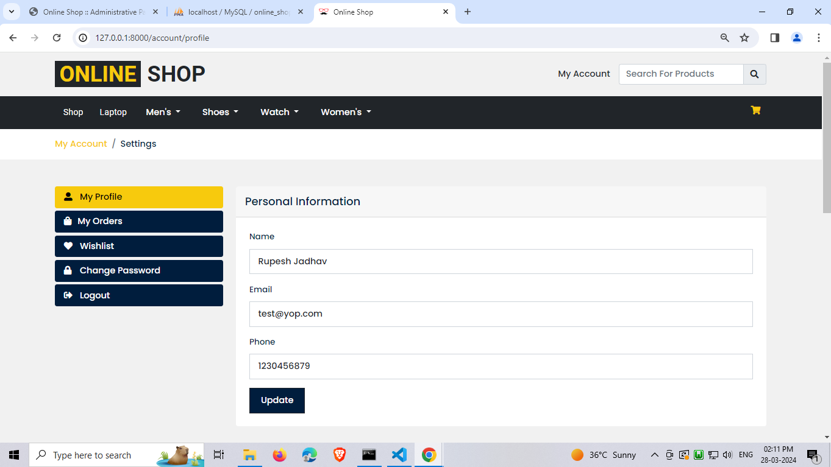**

**Wishlist Page**

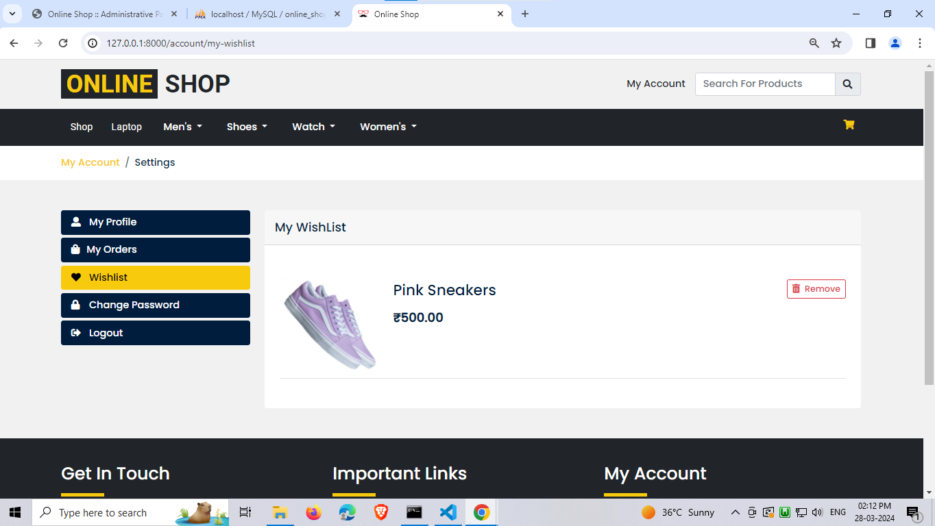

**Admin Side**

**Login Page**

**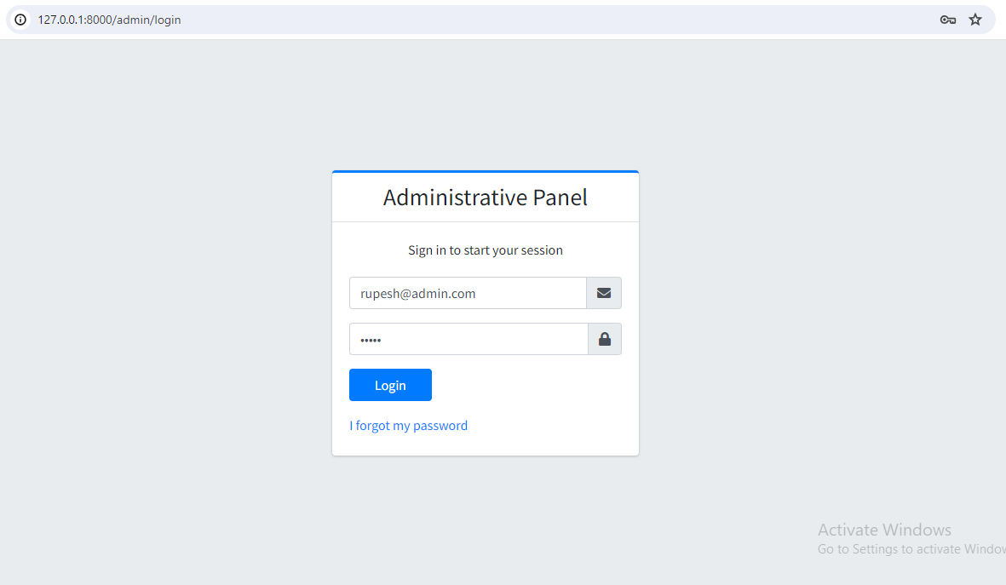**

**Dashboard**

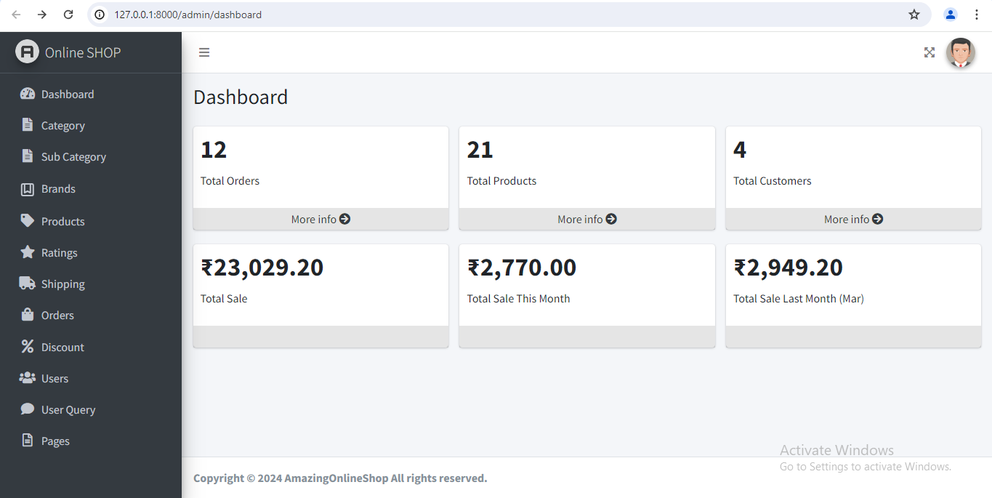

**Category Listing Page**

**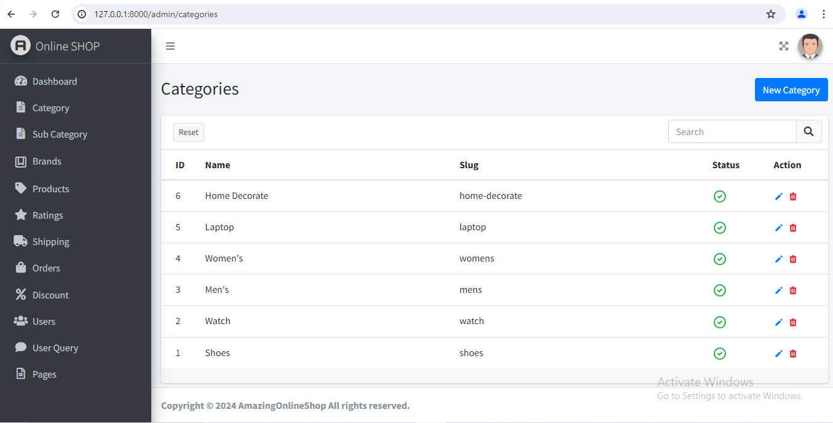**

**Add Category Page**

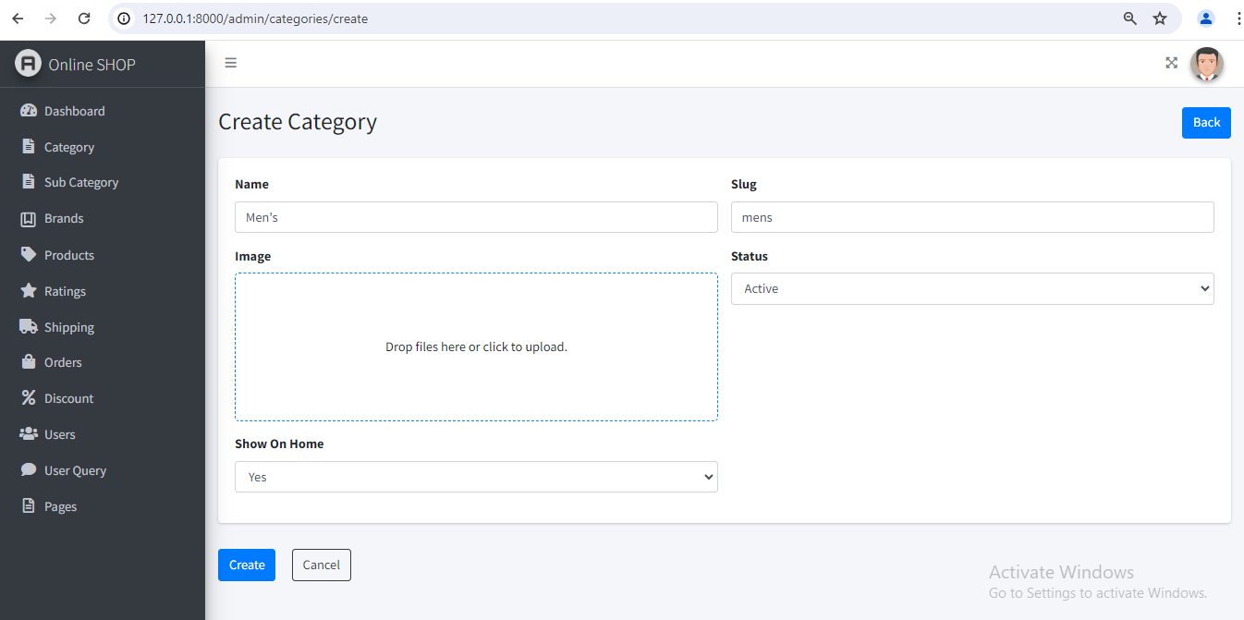

**Product Listing Page**

**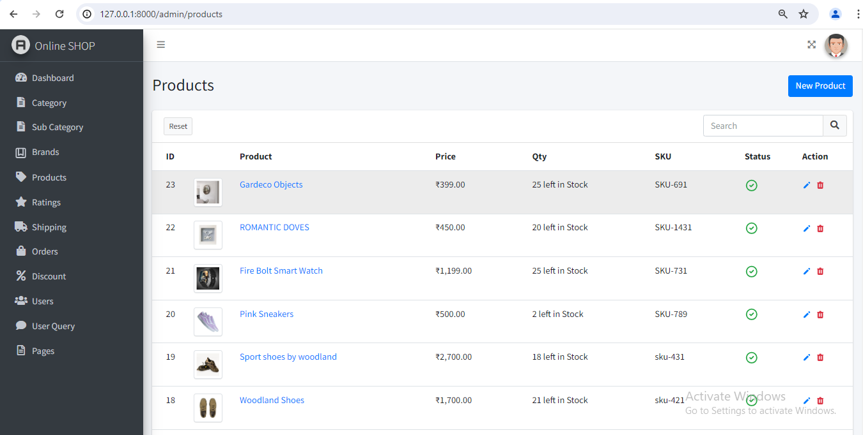**

**Add Product Page**

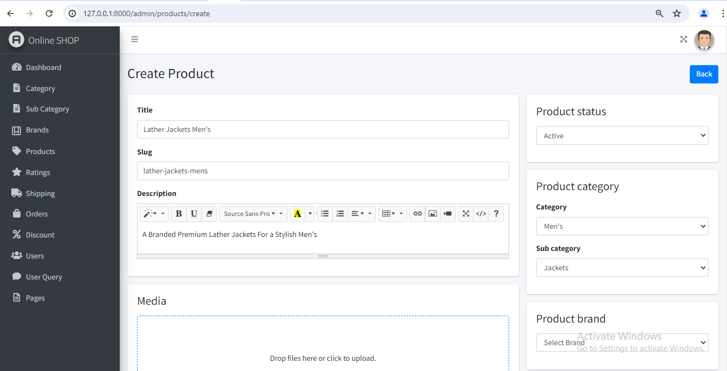

**Shipping Page**

**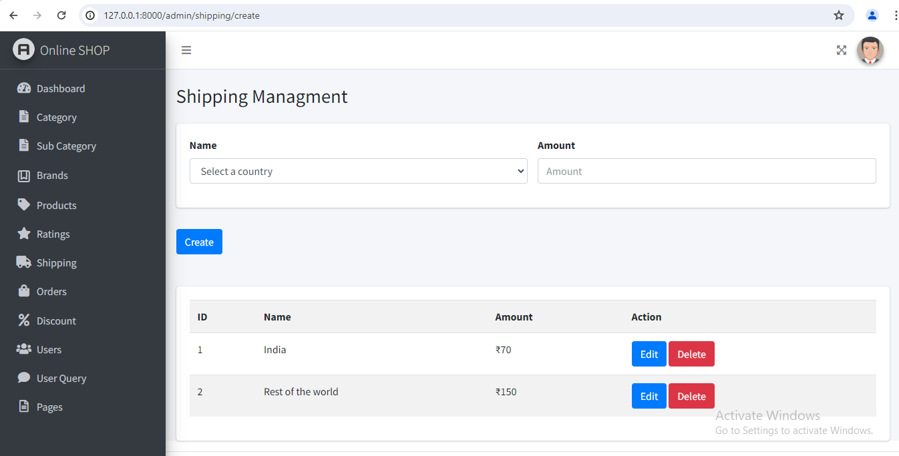**

**Discount Coupon Page**

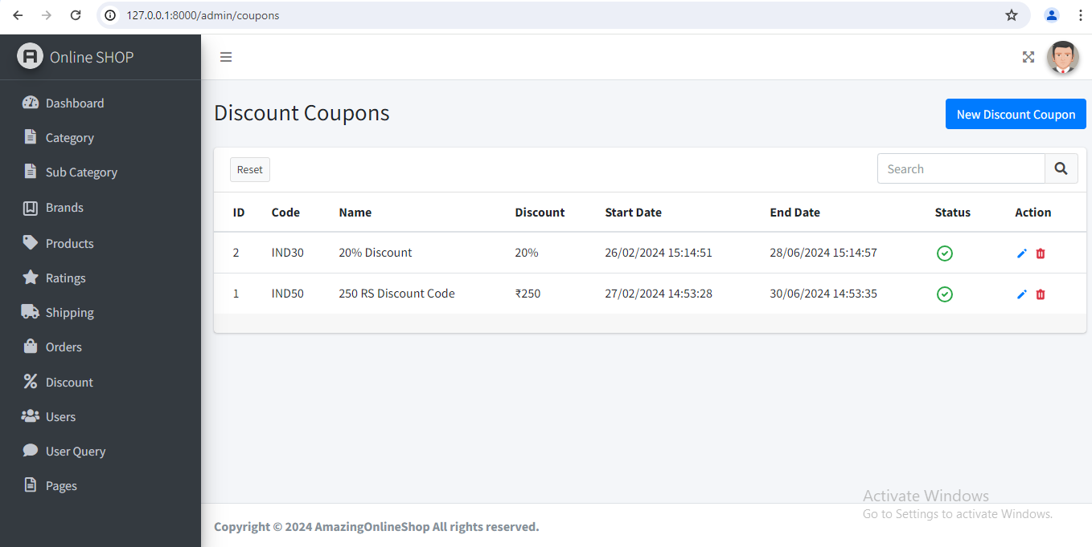

**Order Listing Page Admin**

**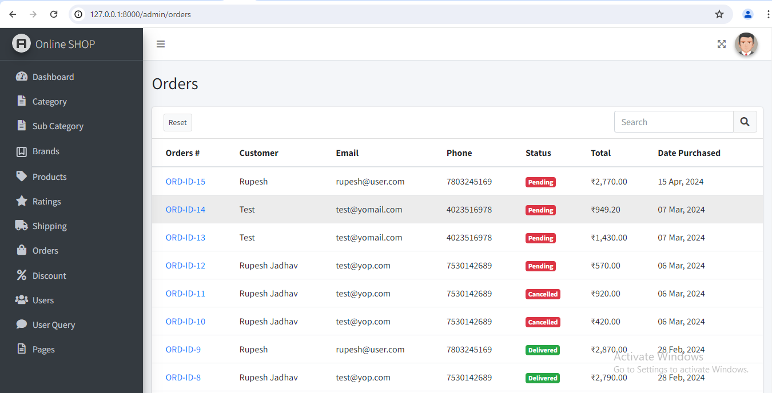**

**Order Details Page Admin**

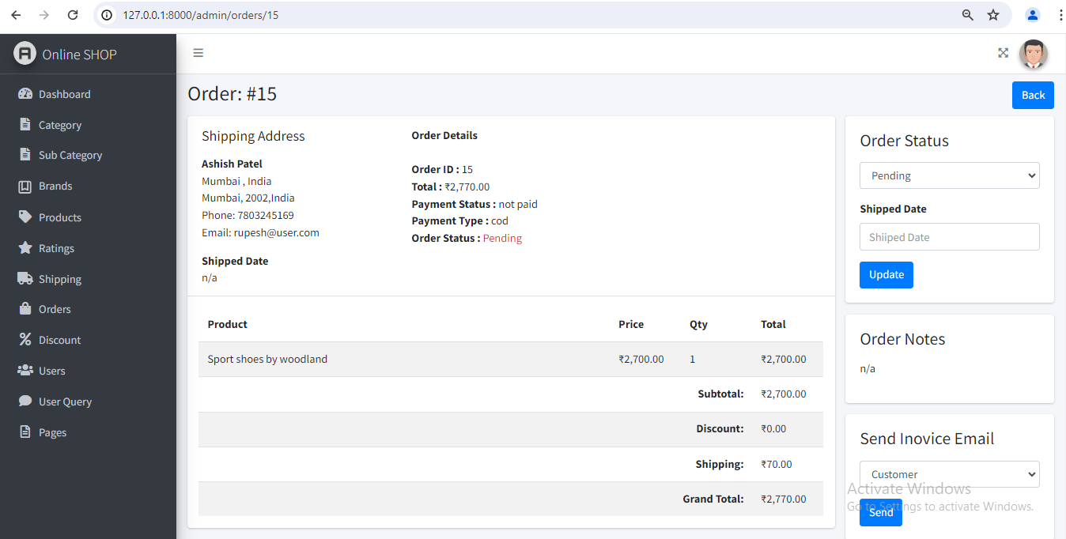

**Agile Project Charter**

|  |  |  |  |  |  |  |  |  |
| --- | --- | --- | --- | --- | --- | --- | --- | --- |
| **Project Charter** | | | | | | | | |
| **Project Title**  **Project Start Date** | Amazing Online Shop | | | | | | | |
| 11/01/2024 | | **Project End Date** | | 23/04/2024 | **Project Sponsor** | | N/A |
| **Business Need** | | | | | | | | |
| This System is Saas (Software as a Service) based platform which provide different type of items buy for without come to shop you can track your order status in our web application. | | | | | | | | |
| **Project Scope** | | | | | | | | |
| The Amazing Online Shop website will provide a platform for customers to browse, select, and purchase a diverse range of products including clothes, accessories, shoes, and home decor items. The Amazing Online Shop will allow users to manage their Orders, cancel their orders, as well as reviews and ratings to the products. | | | | | | | | |
| **Objective** | | | | | | | | |
| Provide an easy-to-use platform for both administrators and users, enabling seamless navigation and interaction to enhance the shopping experience.  Empower administrators with tools to efficiently manage products, categories, brands, orders, users, shipping charges, and discount coupons.  Provide a platform that is flexible and can be customized to meet the unique needs of different types of E-commerce businesses.  Ensure that the platform is secure and reliable, with robust data protection and backup systems in place.  Continuously improve the platform based on user feedback and emerging technologies. | | | | | | | | |
| **Financials** | | | | | | | | |
| **Milestone Schedule** | | | | | | | | |
| **Milestone** | | | | **Target Completion Date** | | | **Actual Date** | |
| Start Date | | | | 11-01-2024 | | | 11-01-2024 | |
| Analyze | | | | 21-01-2024 | | | 25-01-2024 | |
| Improve | | | | 12-02-2024 | | | 27-02-2024 | |
| Completion Date | | | | 12-04-2024 | | | 23-04-2024 | |
| **Project Team** | | Rupesh Jadhav  Mohit Jain  Kashyap Prajapati | | **Approval / Review Committed** | | | | |
| **Project Guide** | | Prof. Zalak Patel | | **Sponsor Body** | | | NA | |

**Agile Roadmap / Schedule**

|  |  |  |  |  |
| --- | --- | --- | --- | --- |
|  | **Month 1** | **Month 2** | **Month 3** | **Month 4** |
| **IMG_256** | 15-Jan-24 | 20-Feb-24 | 25-Mar-24 | 25-Apr-24 |
| **IMG_257** | Version 1 | Version 2 | Version 3 | Version 4 |
| **IMG_258** | Started our Website  Designing | Started Making Modules and Dynamic Admin | Started Implementing it on Front side | Start Testing and Made Documentation |
| **IMG_259** | Completed our website Designing | Completed Making Modules Dynamic Admin | Completed Front Side and make it Dynamic | Completed Testing and Created  Documentation |
| **IMG_260** | 25% | 40% | 75% | 100% |

**Agile Project Plan**

|  |  |  |  |  |  |
| --- | --- | --- | --- | --- | --- |
| **Task Name** | **Priority** | **Owner** | **Start Date** | **End Date** | **Status** |
| **Sprint - 1 - Requirements Mapping and Design a System Flow** | | | | | |
| Gather Requirements and User Stories | High | Rupesh | 12-Jan-24 | 25-Jan-24 | Completed |
| Admin Panel Design | High | Mohit | 26-Jan-24 | 25-Feb-24 | Completed |
| User Side Design | High | Kashyap | 26-Jan-24 | 25-Feb-24 | Completed |
| Define Technical Architecture | High | All Members | 27-Feb-24 | 01-Mar-24 | Completed |
| **Sprint - 2 - Development & Coding** | | | | | |
| Implement User Authentication and Admin Panel | High | Rupesh | 04-Mar-24 | 22-Mar-24 | Completed |
| Developed User Side and Developed Booking System | High | Rupesh | 25-Mar-24 | 18-Apr-24 | Completed |

**Agile User Story**

|  |  |  |
| --- | --- | --- |
| User Story | Role | Reason/Goal |
| As a user, I want to be able to search for products by category so that I can easily find items that match my interests. | User | To facilitate efficient product discovery and navigation within the e-commerce platform. |
| As an administrator, I want to have access to detailed sales reports, so that I can analyze performance and make informed business decisions. | Admin | Improve business operations and optimize sales strategies. |
| As a user, I want to have the option to save products to my Wishlist, so that I can easily access and purchase them later. | User | Facilitate product discovery and streamline the purchasing process for users. |
| As an administrator, I want to be able to set up and manage discount codes, so that I can run promotional campaigns and incentivize purchases. | Admin | Drive sales and customer retention through targeted marketing initiatives. |

**Agile Release Plan**

|  |  |  |  |  |  |  |
| --- | --- | --- | --- | --- | --- | --- |
| Sprint | Task | Start | End | Duration | Release Date | Goal |
| 1 | Project Planning and Research | 12-Jan-24 | 25-Jan-24 | 13 Days | 25-Jan-24 | Understand User Needs and Plan the Project |
| 2 | User Interface Design | 26-Jan-24 | 25-Feb-24 | 31 Days | 25-Feb-24 | Design a User-Friendly Interface |
| 3 | Backend Development and Testing | 04-Mar-24 | 22-Mar-24 | 19 Days | 22-Mar-24 | Develop a Robust Backend and Test its Functionality |
| 4 | Feature Implementation | 25-Mar-24 | 15-Apr-24 | 22 Days | 17-Apr-24 | Implement Key Features Identified During User Research |
| 5 | User Testing and Bug Fixes | 17-Apr-24 | 23-Apr-24 | 7 Days | 23-Apr-24 | Identify and Fix Any Bugs or Issues with the Website |

**Agile Sprint Backlog**

|  |  |  |  |  |
| --- | --- | --- | --- | --- |
| **Task ID** | **Task** | **Estimated Effort (hours)** | **Planned Effort (hours)** | **Status** |
| 1 | User Research and Planning | 50 | 50 | Complete |
| 2 | User Interface Design | 70 | 70 | Complete |
| 3 | Backend Development and Testing | 220 | 220 | Complete |
| 4 | Feature Implementation | 120 | 120 | Complete |
| 5 | User Testing and Bug Fixes | 70 | 70 | Complete |
| 6 | Final Polish and Release | 60 | 60 | Complete |

**Agile Test Plan**

| **Test** | **Action** | **Expected Results** | **Actual Results** | **Pass?** |
| --- | --- | --- | --- | --- |
| 1 | User registration | Should be able to register | User can register | ✔ |
| 2 | User login | Should be able to log in | User can log in | ✔ |
| 3 | User search for products | Should be able to search for products | Products matching search query are shown | ✔ |
| 4 | User add product to cart | Should be able to add products to cart | Product is added to cart successfully | ✔ |
| 5 | User proceed to checkout | Should be able to proceed to checkout | User is directed to checkout page | ✔ |
| 6 | User place order | Should be able to place an order | Order is placed successfully | ✔ |
| 7 | Data save in database | All data should be saved in database | Data is saved in the database | ✔ |

**Proposed Enhancements**

* + Interactive user interface design to make it more user-friendly and visually appealing for the customers.
  + Expand the filtering and sorting options for products, allowing users to refine their search results based on various attributes such as price range, brand, and category. Additionally, implement dynamic sorting options to enable users to sort products by relevance, popularity, price, and other factors.
  + Integrating payment gateway system to allow customers to make online payments for their orders.
  + Developing a real-time analytics dashboard for the shop owners to monitor orders patterns and trends and make informed business decisions.
  + Incorporate user-generated content such as product reviews and ratings into the related products algorithm to enhance the credibility and relevance of recommendations.
  + Enhance the related products algorithm to dynamically analyze user behavior, product attributes, and purchase history to generate more accurate and personalized product recommendations.

**Conclusion**

* In conclusion, the proposed Amazing Online Shop is expected to meet the needs and requirements of the users effectively.
* The enhancements listed above will help to improve the overall user experience and add value to the business.
* The development of a user-friendly interface, real-time analytics dashboard, and integration with payment gateway will improve the convenience and accessibility of the website.
* Developing a website will also increase the ease of access for the customers.
* The successful completion of the project will result in faster Order processing and reduce repetitive work.
* Overall, the proposed enhancements will make the Amazing Online Shop an efficient and effective tool for the customers and the business owners.

**Bibliography**

* [www.youtube.com](http://www.youtube.com)
* [www.stackoverflow.com](http://www.stackoverflow.com)
* <https://laravel.com/>
* <https://www.php.net/manual/en/index.php>
* <https://www.w3schools.com/php/>
* <https://developer.mozilla.org/en-US/docs/Glossary/PHP>
* <https://chat.openai.com/>
* https://app.diagrams.net/